
ABN 56 670 826 212
Rental Agreement
Renter
Name:
Address:
Driver's Licence Number: |  |  |  | Expiry Date: |  | ____/____/____
State / Country of issue: |  |  |  | Date of Birth: |  | ____/____/____
Mobile Number: |  |  |  | Email:
Authorised Driver
Name
Address
Driver's Licence Number: |  |  |  | Expiry Date: | ____/____/____
State / Country of issue: |  |  |  | Date of Birth: | ____/____/____
Mobile number: |  |  |  | Email:
Vehicle
Registration Number:
Odometer Reading  @ Check Out: |  |  |  | @ Check In:
Is the fuel tank full at Start of Rental? |  | [Yes] [No]
Rental Period
Start Date | ___/____/____ |  |  | Start Time |  |  | am/pm
End Date | ____/____/____ |  |  | PAY IN ADVANCE TO EXTEND HIRE
Damage Excess
Payable for Damage, Third Party Loss or theft of the Vehicle |  |  | Up to $ 3000 (plus GST)
Security Bond
Amount payable |  |  | $ 500

Rental Charges
Excess kilometres (more than 800 kms per week) |  |  | @ $0.20 per km |  | $
Missed payment – Payments not made prior to when due incur additional charge |  |  |  |  | $100
Costs of materials – fuel cost to refuel to full tank will be charged at double cost  - Costs related to repairs and cleaning will be charged |  |  |  |  | $
 |  |  |  |  | $
Additional Refuelling Fee – If vehicle not returned with full tank |  |  |  |  | $100
Additional Cleaning Fee – If vehicle not returned clean inside and outside |  |  |  |  | $150
Total Rental Charges (including GST) |  |  |  |  | $
Credit Card Details
Credit Card type | [__] Visa [__] MasterCard [__] Other: _________________
Name on the Card: |  | Expiry Date:
Credit Card Number: |  | CVV Code:
Pre-existing damage
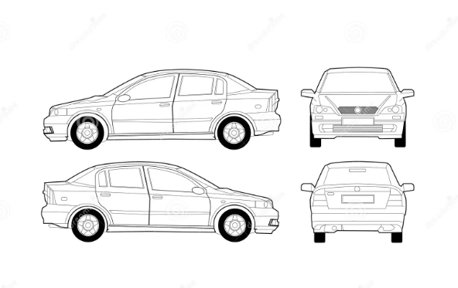 | 1. HIRER MUST TAKE PHOTOS OF VEHICLE CONDITION
 | 2.
 | 3.
 | 4.
 | 5.
 | 6.

I have read the Rental Agreement and the Terms and Conditions and I agree:
- to pay the Rental Charges as shown in the Rental Agreement; and
- to be bound by the Terms and Conditions
Renter signature |  | Date
Authorised Driver signature |  | Date
BY SIGNING THIS RENTAL AGREEMENT YOU ARE AGREEING TO THE HIRE TERMS AND CONDITIONS.
VEHICLES MUST BE RETURNED CLEAN AND FULL FUEL

BANK DEPOSIT PAYMENTS
BANK NAME : ADAPTIVE RESOURCES WA
BSB : 062 692
ACC : 79720428
REFERENCE : ‘Insert the car rego of the vehicle you are hiring as the reference when completing payment’

